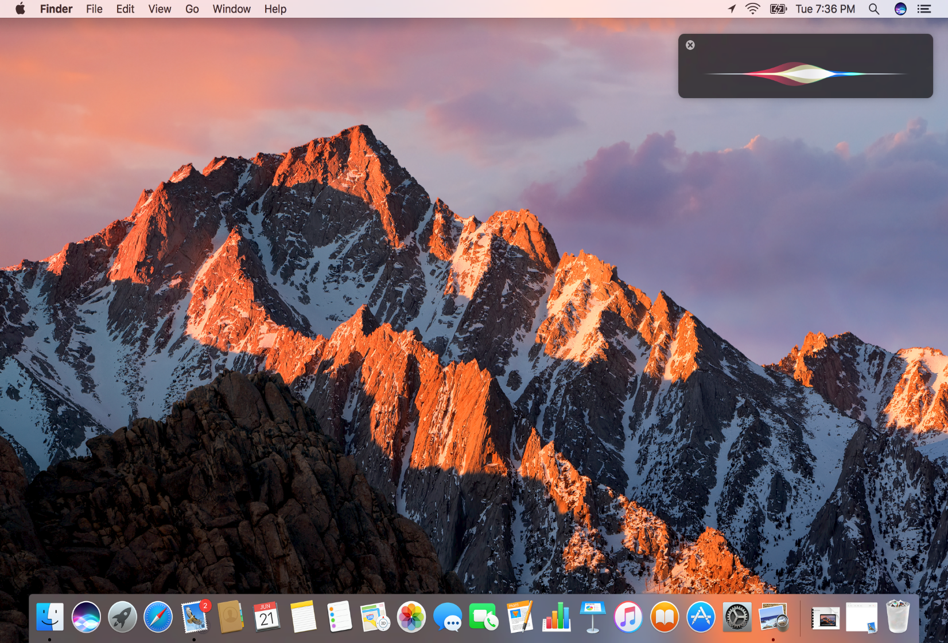

macOS

DANH NGUYEN, BRANDON WHITE, DAVID GABAY | COP4610 – COMPUTER OPERATING SYSTEMS | 11/13/2016

# Brief History

## birth of apple

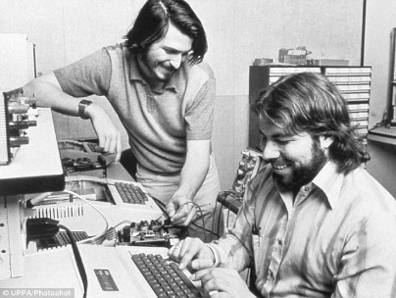 Apple Computer Inc., was founded by Steve Jobs, Steve Wozniak, and Ronald Wayne in 1976. At the time, computers were still very new, primitive, bulky, and expensive. Jobs and Wozniak were visionaries and technological pioneers who wanted to create “personal computers,” that will cater to everyone, making it relatively small enough for offices and households. Both men started out building Apple I within Job’s garage, initially sold without a monitor, keyboard, or casing but was later added on in 1977. Apple II revolutionized the computer industry with the introduction of the first-ever color graphics which skyrocketed the company financially allowing them to go public. In 1983, Jobs elected a new CEO into the company, John Sculley, known for being the youngest president of PepsiCo. In the same year, his friend Wozniak left Apple due to growing disinterest in the company going as far as selling all his shares.

## fired from apple

Within two years after Sculley takes position as CEO of Apple, tension between him and Jobs start to heat up. Jobs believed greatly in the Apple Lisa team and wanted to cut budget from other sectors of the company to increase the price of a product that did not sell as well as anticipated. However, Apple II was Apple’s only resource that was generating consistent revenue but Jobs wanted to decrease Apple II’s budget to focus it on the Lisa Team. This conflict among many others between Sculley and him inevitably resulted with Jobs being ousted by Apple.

## Next software

In the same year, Jobs founded a new company, NeXT Inc. In 1988 an invitation only launch event NeXT was held at the War Memorial Opera House in San Francisco, California. This event served as an insight into the software architecture and developing for the NeXT Computer. The following year, NeXT created NeXTSTEP a UNIX based Operating System for its computers.

## Mac is back

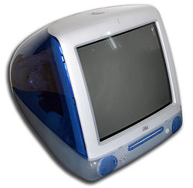 Over the course of 1990 and 1996, Apple did not fare well leaving experts to believe it may well be nearing its demise. Desperate to obtain an OS like Microsoft, it bought out NeXT Software, for its Unix-based Operating System NeXTSTEP. In addition to obtaining an OS, Apple took back Steve Jobs as iCEO until 2000 when he officially became CEO again. Jobs restructured Apple, out with the old and in with the new. In 1998, Apple unveiled its most innovative inventions ever, the iMac G3. The iMac G3 was such a success during the month of release, it was the sole product that revitalized Apple financially. The iMac G3 initially ran on Mac OS 8 which was an Operating System of Macintosh. As technology improved, so did the Operating System which has evolved through years of innovation to what is now known today as Mac OS X.

# Introduction

## Why we chose mac

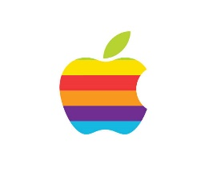We chose macOS because it is such an interesting operating system that has evolved to a beautifully masterful piece of art that caters to billions of users in today’s technology in some way or another. It’s ease of use and most of all simple layout and design is the epitome of usability that took decades of evolution to obtain. Not only that, Apple has made a mark in many of our schools by integrating their computers in our youthful lives at one point. Though it’s hard for some to see an Operating System as a piece of art, Apple’s macOS is truly a piece of art that deserves respect.

## description

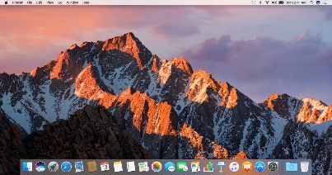The Mac OS X underwent a series of rebranding over the years beginning 2012 to 2016. Today it is called macOS. It is a Unix-based graphical operating system, that was released on March 24, 2001. It is the latest of Macintosh operating systems that is based off NeXT software. The first version of Mac OS required 128MB of RAM and 1.5GB of hard drive space. Mac OS Sierra (current version as of September 2016) now requires 2GB of RAM and 8.8GB of hard drive space. Building on the open source operating system core, Darwin, Mac OS X is acclaimed for its usability, security, performance, and reliability. Mac OS X was designed with a simpler user interface than competing operating systems for PCs such as Windows and Linux. Apple has partnered with current president Barack Obama to deliver over 2,930 computer systems to k-12 schools throughout the country the first year. All of Apple Computer’s Macintosh run on some version of Mac OS X.

## types of computers that use mac os x

It was on January 7, 2002 that Apple declared that all Macs will have Mac OS X as their default Operating System. In other words, the Power Mac G5, xServe, MacBook, Mac Pro, and iMac from 2002 onwards are all computer products that come with Mac OS X installed.

# OS Architecture

## 

# 